**Day 4: Make Functional Components of Website**

**1. Product Listing Component:**

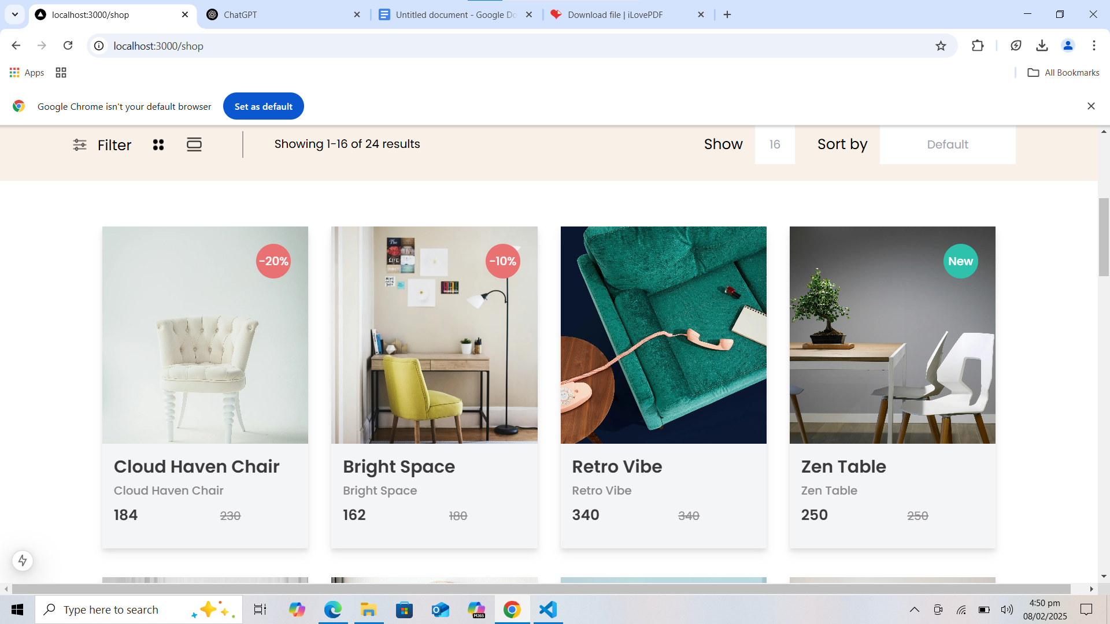

Render product data dynamically in a grid layout. Include fields like:

o Product Name

o Price

o Image

o Stock Status

Example layout: cards displaying product details.

Code Snippets:

'use client'

import Image from "next/image";

import { Product } from "../types/Product";

import { useEffect, useRef, useState } from "react";

import Link from "next/link";

export default function Shopproducts({productList,mainvalue}:{productList:Product[],mainvalue:number})

{

// const [showingProduct,_setShowingProduct]=useState(1);

const [defaultValue,setDefaultValue]=useState(mainvalue);

const inputdefaul_value=useRef<HTMLInputElement>(null);

function handleinput(event:React.KeyboardEvent)

{

if(event.key === "Enter" && inputdefaul_value.current)

{

const setvalue = inputdefaul_value.current.value;

if(!isNaN(Number(setvalue)))

setDefaultValue(Number(setvalue));

}

} //Yhan Bar Line kA code he

const [Page,setPage]= useState<Array<number>>([1,2,3]); //Niche Page k liye Sara Code he

const [currentpage,setCurrentPage]=useState(1);

const Product_length=productList.length;

const [ShowData,setShowData]=useState<Product[]>([]);

function handlePageChange(pageIndex: number=0) {

const start = (Page[pageIndex]-1)*defaultValue; //konsa Product Phle ay ga start page[0]-1 = 0*defaultValue=0

let end=(Page[pageIndex])*defaultValue; // End Konse Product Pr ho ga page[0]=1*defaultvalue=1 *16=16

end= end > Product_length ? Product_length : end;

if(Page[pageIndex]!==currentpage && start<Product_length){ //Same Page pr kam nhi kare ga Ya me ne start ko value Zayada de di to kam nhi kaere

const Data=productList.slice(start,end); //Ek specific range me product nikalna

setShowData(Data);

if(Page[pageIndex]>currentpage && pageIndex==2)

{

setCurrentPage(Page[pageIndex]);

setPage([Page[1],Page[2],Page[2]+1]);

}else if(Page[pageIndex]<currentpage && pageIndex==0)

{

setCurrentPage(Page[pageIndex]);

if(Page[pageIndex]!==1)

setPage([Page[0]-1,Page[0],Page[1]]);

}else{

setCurrentPage(Page[pageIndex]);

}

}

}

function HandleNext(){

let check=Math.ceil(Product_length/defaultValue); // 24 / 16 = 2 total pages

if(check>Page[2])

{

check=check-Page[2] >3 ? 3 : check-Page[2];

setPage([Page[0]+check,Page[1]+check,Page[2]+check]);

}

}

useEffect(()=>{

const end=defaultValue >Product_length ?Product_length:defaultValue;

const Data=productList.slice(0,end);

setCurrentPage(1);

setPage([1,2,3])

setShowData(Data);

},[defaultValue])

return(

<div>

<div>

<div className="relative w-full h-[100px] bg-[#F9F1E7] flex">

<div className="flex gap-3 ml-[98px] pt-[37px]">

<div className="relative w-[25px] h-[25px]"><Image src={"/shop/filter.png"} alt="" width={19.05} height={16.67} className="absolute top-[4.76] left-[2.98px]"></Image> </div>

<h1 className="text-xl font-normal">Filter</h1>

</div>

<div className="ml-[23px] pt-[36px] h-7 w-[100px] flex gap-6 ">

<div className="relative w-7 h-7">

<Image src={"/shop/fourdots.png"} alt="" width={16.33} height={16.33} className="absolute top-[5.83px] left-[5.83px]"></Image>

</div>

<div className="relative w-6 h-6 ">

<Image src={"/shop/decorate.png"} alt="" width={21} height={19.5} className="absolute top-1 left-[1.5px]"></Image>

</div>

</div>

<div className="ml-[30px] mt-[31px] border-l-2 border-[#9F9F9F] w-[237px] h-[37px]">

<p className=" w-[220px] h-6 text-[16px] font-normal text-center ml-[34px] pt-1.5">

Showing {(currentpage-1)*defaultValue + 1}-{currentpage*defaultValue > Product_length ? Product_length : currentpage*defaultValue} of {productList.length} results

</p>

</div>

<div className="absolute right-0 w-32 h-[55px] mr-[417px] flex items-center gap-[17px] top-[22px]">

<h1 className="text-xl font-normal">Show</h1>

<input type="text" ref={inputdefaul_value} placeholder={defaultValue.toString()} onKeyDown={handleinput} className="w-[55px] h-[55px] outline-none border-none text-center"/>

</div>

<div className="absolute right-0 top-[22px] mr-[100px] w-[288px] h-[55px] flex gap-[17px] items-center">

<h1 className="text-xl font-normal">Sort by</h1>

<input type="text" placeholder="Default" className="w-[188px] h-[55px] outline-none border-none text-center"/>

</div>

</div>

</div>

<div className="w-full mt-[63px] flex flex-col justify-center items-center">

<div className="mx-[5%] flex flex-wrap gap-x-8 gap-y-10 justify-center">

{

ShowData.length > 0 ? (

ShowData.map((product: Product) => (

<div key={product._id} className='relative w-[285px] h-[446px] '>

<div className='group bg-black drop-shadow-lg hover:scale-105 transform duration-300'>

<div className='relative w-[285px] h-[301px] group-hover:opacity-50 transform duration-300'><Image src={product.imageurl} alt={product.title} layout='fill' objectFit='cover' />

<div className={`absolute grid items-center text-[16px] font-medium text-white justify-center w-12 h-12 ${product.isNew == true ? "bg-[#2EC1AC]" : product.dicountPercentage >0 ?"bg-[#E97171]":"hidden"} top-6 left-[213px] rounded-full`}>

<h1>{product.isNew == true ? "New":"-"+product.dicountPercentage+"%"}</h1>

</div>

</div>

<div className='relative w-[285px] h-[145px] bg-[#F4F5F7] group-hover:opacity-50 transform duration-300'>

<h1 className={`absolute top-4 left-4 w-[285px] h-[29px] text-2xl font-semibold text-[#3a3a3a]`}>

{product.title}

</h1>

<h1 className={`absolute top-[53px] left-4 w-[285px] h-[29px] text-[16px] font-medium text-[#898989]`} >

{product.title}

</h1>

<h1 className={`absolute top-[85px] left-4 w-[285px] h-[29px] text-xl font-semibold text-[#3a3a3a]`} >

{product.dicountPercentage !=0 ? product.price - (product.price * product.dicountPercentage / 100) : product.price }

</h1>

<h1 className={`absolute top-[88px] left-[163px] w-[285px] h-[29px] text-[16px] font-normal line-through text-[#898989]`} >

{product.dicountPercentage!=0? product.price : product.price }

</h1>

</div>

<div className='absolute top-[175px] left-4 w-[252px] h-24 grid grid-cols-1 gap-6 justify-items-center text-[16px] font-semibold text-white opacity-0 group-hover:opacity-100 transform duration-300'>

<Link href={`product/${product.slug}`}> <button className='w-[202px] h-12 bg-white text-[#B88E2F] grid justify-center items-center active:bg-slate-300 rounded-lg transition-transform transform active:scale-95'>

<p>Add to cart</p>

</button> </Link>

<div className='w-[252px] h-6 flex gap-5'>

<button className='w-[66] h-6 flex gap-[2px] justify-center items-center'><div className='relative w-4 h-4'><Image src="/Home/share.png" alt="" width={12} height={13.33}></Image></div>

<h1 className='w-12 h-6'>Share</h1></button>

<button className='w-24 h-6 flex gap-[2px] justify-center items-center'><div className='relative w-4 h-4'><Image src="/Home/compare.png" alt="" width={13.1} height={14} ></Image></div>

<h1 className='w-[78px] h-6'>Compare</h1></button>

<button className='w-[50] h-24 flex gap-[2px] justify-center'><div className='relative w-4 h-4'><Image src="/Home/like.png" alt="" width={13.84} height={11.9} className='mt-1.5'></Image></div>

<h1 className='w-8 h-6'>Like</h1></button>

</div>

</div>

</div>

</div>

))

) : (

<p>No ShowData available</p>

)}

</div>

<div className="mt-[4%] w-[392px] h-[60px] flex justify-center gap-[38px] text-xl font-normal">

{

Page.map((ele,index)=>{

return(

<button onClick={()=>{handlePageChange(index)}} key={index} className={`w-[60px] h-[60px] ${currentpage==ele ?"bg-[#B88E2F] text-white" : " bg-[#F9F1E7] text-black"} ${((ele -1)*defaultValue ) >=Product_length ? "hidden" : ""} rounded-[10px] grid justify-center items-center`}>

{ele}

</button>

)

})

}

<button onClick={HandleNext} className="w-[98px] h-[60px] bg-[#F9F1E7] rounded-[10px] ">Next</button>

</div>

</div>

</div>

)

}

Documentation:

To implement this, I followed these steps:

1. First, I fetched the data using Sanity.
2. Then, I passed this data to the client component using props technique.
3. In the client component, I defined types and fetched the data according to those types.
4. I used the map function on a useState variable to display the data.
5. I created a useState variable to show products with a discount or "new" tag.
6. For products with a discount greater than 0, I calculated the price as price - (discount/100) * price.

**Product Detail Component:**

* Create individual product detail pages using dynamic routing in Next.js.
* Include detailed fields such as:
* Product Description
* Price
* Available Sizes or Colors

import { client } from "@/sanity/lib/client";

import Barline from "./productcomponent/bar";

import ProductCard from "./productcomponent/DescriptionProduct";

// Notice the change here: params is typed as a Promise that resolves to an object with slug.

export default async function Post({

params,

}: {

params: Promise<{ slug: string }>;

}) {

// Await params to get the actual object.

const { slug } = await params;

const Data = await client.fetch(

`*[_type == "product" && slug.current == "${slug}"]

{

_id,

title,

_type,

price,

dicountPercentage,

description,

isNew,

tags,

"slug": slug.current,

"imageurl": productImage.asset->url

}`

);

// Optional: Check if the product exists.

if (!Data || Data.length === 0) {

return <div>Product not found</div>;

}

let Desc: string = Data[0].description;

// Trim the description up to "Key Features:" if found.

Desc = Desc.substring(0, Desc.indexOf("Key Features:"));

return (

<div>

<Barline title={Data[0].title} />

<ProductCard product={Data[0]} />

<div className="border-t border-gray-300">

<div className="mt-12 text-2xl font-medium flex items-start justify-center">

<p>Description</p>

</div>

<div className="mt-[37px] mx-[5%] text-justify">{Desc}</div>

</div>

</div>

);

}

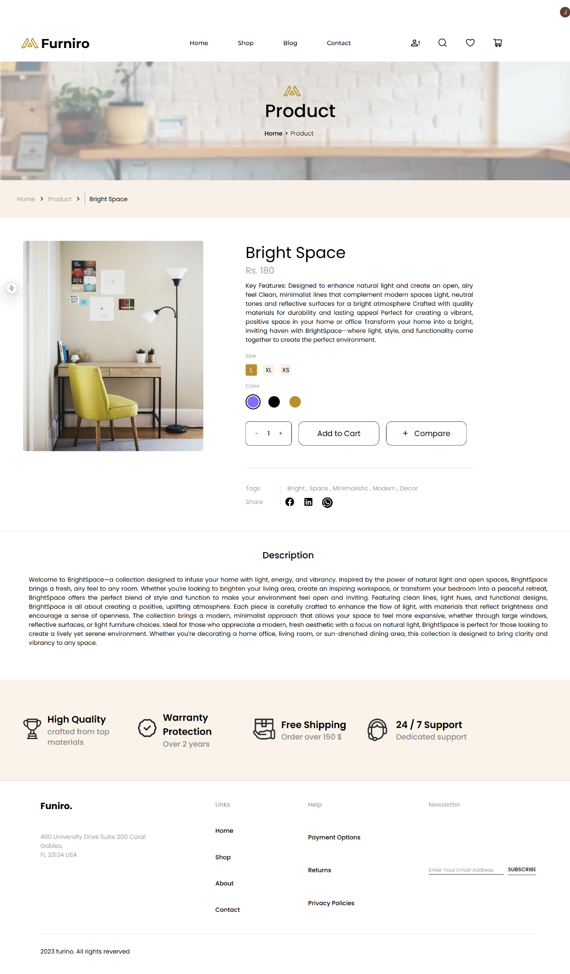

### **Documentation Summary**

* **Steps Taken**:  
  1. Fetched product data from Sanity CMS based on the product slug.
  2. Passed data to client-side components (Barline, ProductCard) using props.
  3. Integrated dynamic features like tags, descriptions, and price calculation with discounts.
  4. Created responsive layout and handled user inputs (quantity, size, color).
  5. Added social media sharing options (Facebook, LinkedIn, WhatsApp).
* **Challenges & Solutions**:  
  1. **Data Fetching**: Handled missing data by displaying a fallback message.
  2. **User Inputs**: Managed dynamic user selections (quantity, size, color) using useState.
  3. **Description Parsing**: Trimmed descriptions to show key features only.
* **Best Practices**:  
  1. **Component Separation**: Maintained reusable components (Barline, ProductCard).
  2. **Responsive Design**: Ensured layout adaptability across devices.
  3. **Error Handling**: Managed errors like missing product data for better user experience.

**Category Component:**

* Display categories dynamically fetched from the data source.
* Enable filtering of products by selected categories.

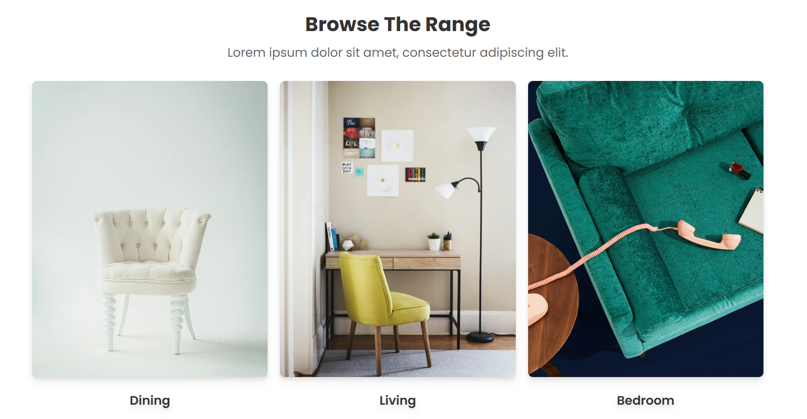

// components/homecomponents/category.tsx

import poppin from "../globalcomponents/Poppin";

import { client } from "@/sanity/lib/client";

import Image from "next/image";

import Link from "next/link";

interface Props {

Name: string;

img_src: string;

}

export const Category_Show = async () => {

const Data = await client.fetch(

`*[_type =="product"][0..2]{ "imageurl": productImage.asset->url }`

);

const Cataglist: Props[] = [

{ Name: "Dining", img_src: Data[0].imageurl },

{ Name: "Living", img_src: Data[1].imageurl },

{ Name: "Bedroom", img_src: Data[2].imageurl },

];

return (

<section className="relative py-12 px-4 md:px-8">

<h1

className={`

text-center font-bold text-[#333333] ${poppin.className}

text-[24px] sm:text-[28px] md:text-[32px]

`}

>

Browse The Range

</h1>

<p

className={`

text-center text-[#666] ${poppin.className}

text-lg sm:text-xl mt-2

`}

>

Lorem ipsum dolor sit amet, consectetur adipiscing elit.

</p>

<div className="mt-8 flex flex-wrap justify-center gap-5">

{Cataglist.map((ele, index) => (

<Link href={""} key={index} className="w-full sm:w-[381px]">

<div className="grid gap-6 justify-items-center drop-shadow-lg">

<div className="relative w-full h-[300px] sm:h-[480px]">

<Image

src={ele.img_src}

alt={ele.Name}

layout="fill"

objectFit="cover"

className="rounded-lg"

/>

</div>

<h1 className="text-center text-[#333] text-xl font-semibold">

{ele.Name}

</h1>

</div>

</Link>

))}

</div>

</section>

);

};

### **Documentation Summary**

* **Steps Taken**:  
  + Fetched the first three product images from Sanity CMS.
  + Defined a Props interface for category data.
  + Dynamically populated the category list and displayed it using responsive design with next/image for optimized images.
  + Created clickable category cards with Link.
* **Challenges & Solutions**:  
  + Handled dynamic data fetching with async/await for smooth integration.
  + Ensured responsiveness across devices using Tailwind CSS.
* **Best Practices**:  
  + Used reusable components, optimized images, and defined clear interfaces for maintainability.

Cart Component:

* Display
* added items,
* quantity
* total price.
* Use state management for tracking cart items.

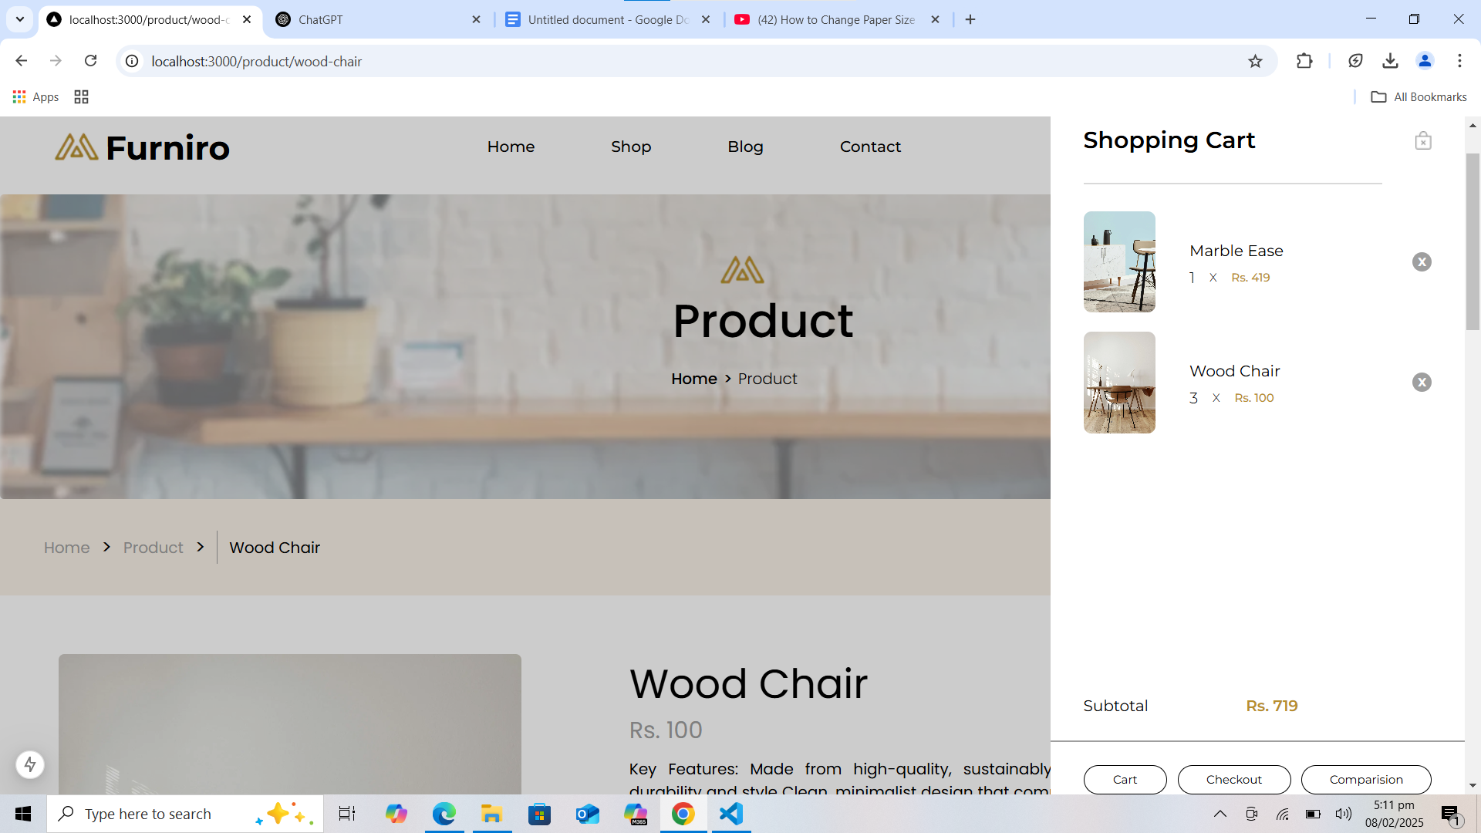

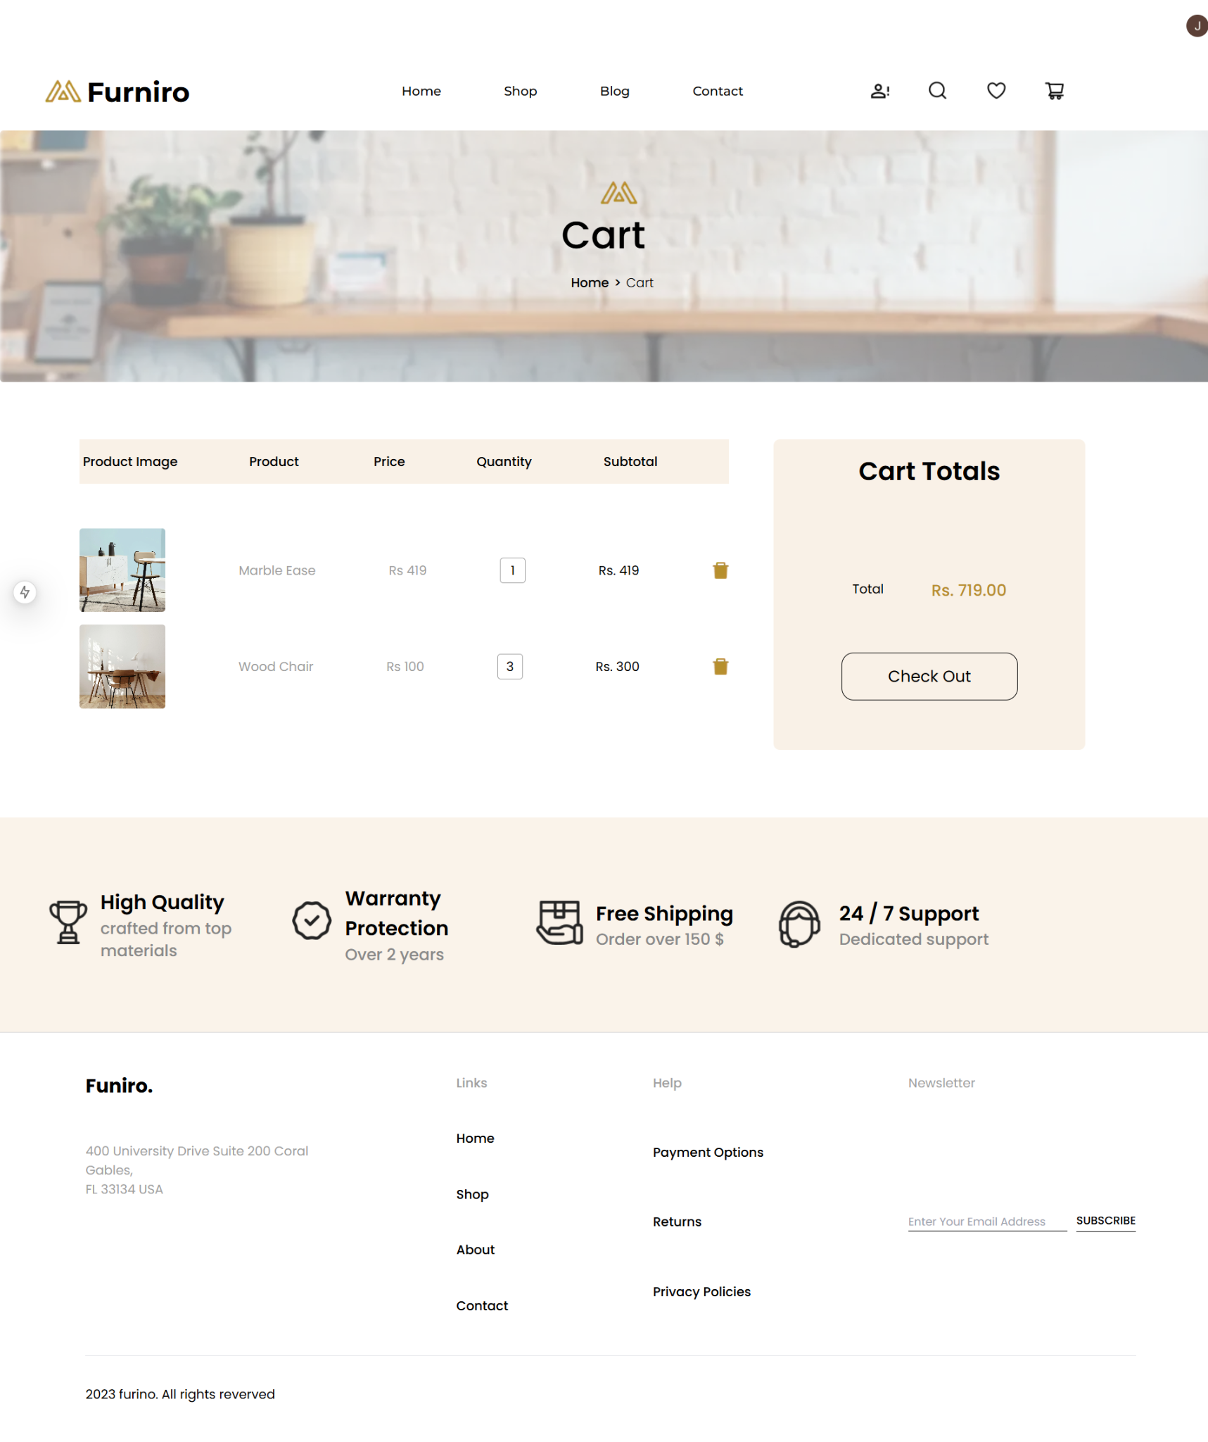

'use client'

import Image from "next/image"

import Link from "next/link"

import { useEffect, useState } from "react";

import { Producttype } from "../components/types/Product";

export default function Cart() {

const [products, setProducts] = useState<Producttype[]>([]);

const [total, setTotal] = useState(0);

useEffect(() => {

const cart = JSON.parse(localStorage.getItem('cart') || '{}') as Producttype;

const items = Object.values(cart);

setProducts(items);

let dummytotal = 0;

for (const i of items) {

dummytotal += i.price * i.Quantity;

}

setTotal(dummytotal)

console.log(items)

}, []);

const removeproduct = (ele: Producttype) => {

const cart = JSON.parse(localStorage.getItem('cart') || '{}');

delete cart[ele.title];

localStorage.setItem('cart', JSON.stringify(cart));

setProducts(Object.values(cart))

setTotal(total - (ele.price * ele.Quantity))

}

return (

<div className=" mt-[72px] flex gap-14">

<div className="flex flex-col gap-y-14 ml-[100px]">

<div className=" w-[817px] h-14 bg-[#F9F1E7] grid items-center">

<div className=" flex justify-between text-[16px] font-medium">

<h1 className="whitespace-pre"> Product Image</h1>

<h1>Product</h1>

<h1 className="whitespace-pre"> Price</h1>

<h1>Quantity</h1>

<h1>Subtotal</h1>

<h1></h1>

</div>

</div>

<div className="grid text-[16px] text-[#9F9F9F] font-normal gap-y-4">

{products.map((ele) => (

<div key={ele._id} className="flex justify-between items-center ">

<div className="relative w-[108px] h-[105px]"> <Image src={ele.imageurl} alt="" layout="fill" objectFit="cover" className="rounded"></Image></div>

<h1>{ele.title}</h1>

<h1>Rs {ele.price}</h1>

<h1 className="w-8 h-8 border border-[#9F9F9F] text-black grid items-center justify-center rounded">{ele.Quantity}</h1>

<h1 className="text-black">Rs. {ele.price * ele.Quantity}</h1>

<button onClick={() => { removeproduct(ele) }}> <Image src={"/delete.png"} alt="" width={21} height={21.88}></Image></button>

</div>

))}

</div>

</div>

<div className=" w-[392px] h-[390px] bg-[#F9F1E7] flex items-center flex-col rounded-lg">

<h1 className="mt-4 text-[32px] font-semibold">Cart Totals</h1>

<div className="flex gap-[60px] mt-28 ">

<p>Total</p>

<h1 className="text-xl text-[#B88E2F] font-medium">Rs. {total}.00</h1>

</div>

<Link href="./checkout"> <button disabled={total == 0} className={`w-[222px] h-[60px] border border-black rounded-[15px] mt-16 text-xl font-normal hover:w-[236px] hover:h-16 hover:bg-[#B88E2F] transform duration-300 hover:text-white ${total == 0 ? "cursor-not-allowed" : ""}`}>Check Out</button> </Link>

</div>

</div>

)

}

### **Documentation Summary**

* **Cart Management**:  
  + Fetches product data from localStorage.
  + Displays product details: image, price, quantity, and subtotal.
  + Allows removal of products from the cart.
* **Total Calculation**:  
  + Dynamically updates the total price based on product quantity.
  + Adjusts the total when items are removed.
* **UI/UX**:  
  + Disables the checkout button when the cart is empty.
  + Uses Tailwind CSS for responsive, clean design.
* **Real-time Updates**:  
  + Updates cart data and UI dynamically when products are added or removed.

**Checkout Flow Component:**

* Create a multi-step form for checkout, including fields for:
* Billing and shipping address
* Payment details (mock implementation)

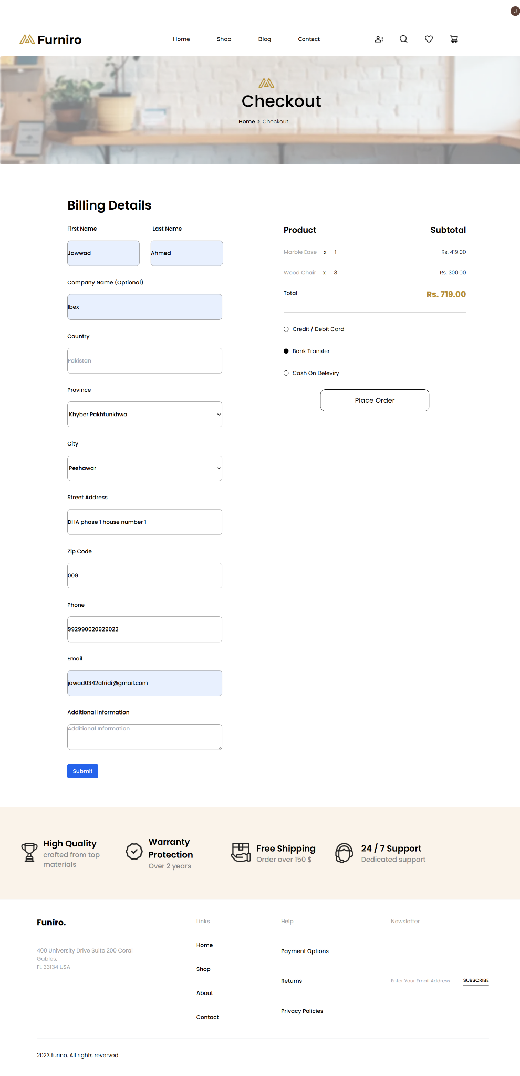

### **Documentation Summary:**

#### **1. Steps Taken to Build and Integrate Components:**

* Managed form data and product details using useState.
* Fetched cart data from localStorage and calculated the total price.
* Integrated useUser hook from @clerk/nextjs to fetch user ID.
* Created a dynamic payment method selection with three options.
* Implemented a dynamic city dropdown based on the selected province.
* Submitted order data to an API endpoint for order creation and cleared the cart.

#### **2. Challenges and Solutions:**

* **Cart Management**: Handled dynamic cart data and total calculation via useEffect.
* **User ID Handling**: Integrated useUser to retrieve the user ID and set it in the form.
* **Payment Method Selection**: Ensured only one payment method can be selected at a time using state.
* **Province-City Mapping Manually** : Used a mapping object to filter cities based on the selected province.

#### **3. Best Practices Followed:**

* Kept components modular for maintainability.
* Used useState for managing dynamic form data and cart information.
* Implemented error handling for API submission.
* Added form validation for required fields.
* Used conditional styling to highlight the selected payment method.
* Cleared the cart upon successful order submission to avoid outdated data.
* Ensured a reactive UI that updates based on state changes.

**User Profile Component:**

* Display user-specific details like:
* Name, email, and saved addresses.  
  Order history with links to individual orders.

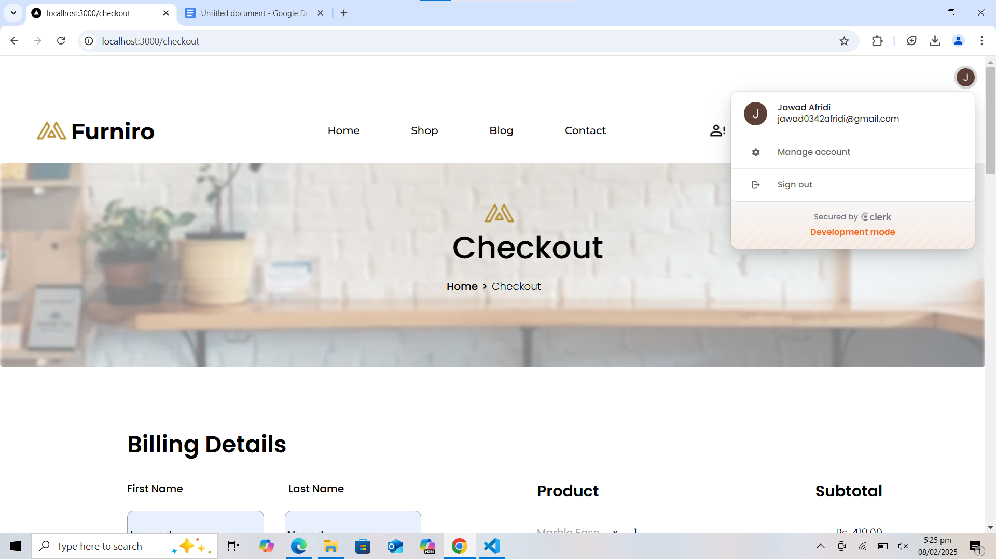

Order In Database’

### **Clerk Implementation in Next.js - Summary**

#### **1. Steps Taken to Build and Integrate Clerk:**

* **Install Clerk SDK**: Installed @clerk/nextjs using npm.
* **Configure Clerk**: Set up Clerk API keys in .env file.
* **Clerk Provider**: Wrapped the root component (_app.js or _app.tsx) with ClerkProvider.
* **Sign-In/Sign-Up Pages**: Integrated Clerk's pre-built SignIn and SignUp components.
* **Access User Data**: Used useUser hook to access user information like user ID and email.
* **Protect Routes**: Used RedirectToSignIn or withClerk to protect routes for authenticated users.
* **Session Management**: Handled user session automatically with Clerk.

#### **2. Challenges and Solutions:**

* **Challenge**: Integrating custom authentication pages.
  + **Solution**: Used Clerk's pre-built UI components (SignIn and SignUp).
* **Challenge**: Managing authentication state in a stateless framework.
  + **Solution**: Leveraged useUser hook for centralized user data management.
* **Challenge**: Protecting routes.
  + **Solution**: Implemented RedirectToSignIn for route protection.
* **Challenge**: Handling redirects and session persistence.
  + **Solution**: Used Clerk's session management features to handle redirects automatically.

#### **3. Best Practices Followed:**

* **Environment Variables**: Stored sensitive information like API keys in .env files.
* **Session Management**: Used Clerk's automatic session handling for persistence.
* **UI Customization**: Styled Clerk’s UI components with Tailwind CSS to match app’s design.
* **Redirection Logic**: Applied RedirectToSignIn for seamless redirection of unauthenticated users.
* **User Data Access**: Utilized useUser hook for consistent access to user data.

#### **4. Conclusion:**

Clerk streamlines user authentication and session management in Next.js. With minimal configuration, Clerk offers secure authentication, easy session handling, and route protection, ensuring a smooth user experience and reducing manual management of user states.

**Order Dealing:**

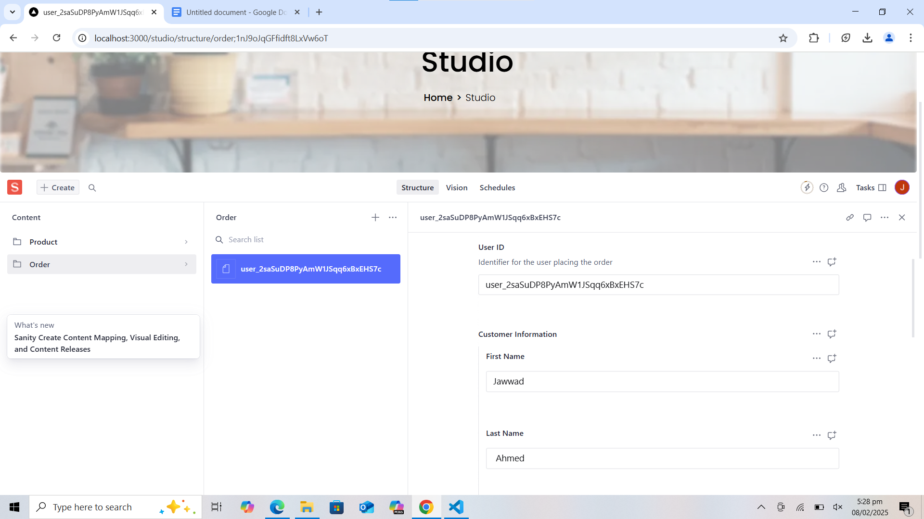

### **Order Creation and Submission - Summary**

#### **1. Steps Taken to Build and Integrate Order API:**

* **Sanity Client Setup**: Configured @sanity/client to connect with the Sanity CMS using environment variables for project ID, dataset, and API token.
* **POST Request Handling**: Implemented an API route (/api/orders) to handle order submissions.
* **Sanity Document Creation**: On receiving the POST request, created an order document in Sanity with customer and order details.
* **Order Structure**: The order document includes customer information, shipping address, ordered products, and payment details.
* **Response Handling**: Returns a success or failure response after creating the order document.

#### **2. Challenges and Solutions:**

* **Challenge**: Ensuring that all order details are correctly submitted and stored.
  + **Solution**: Used create method in Sanity client to store the order data in a structured manner.
* **Challenge**: Handling errors and providing meaningful feedback to the user.
  + **Solution**: Implemented a try-catch block to capture errors and return proper error messages.

#### **3. Best Practices Followed:**

* **Environment Variables**: Securely stored API keys and project details using environment variables.
* **Error Handling**: Used try-catch for error management and provided meaningful error responses.
* **Data Validation**: Ensured that the order data, including user information, shipping address, and payment method, is correctly formatted before submission.

#### **4. Steps Taken to Build and Integrate Order Submission in Frontend:**

* **Form Data Submission**: On form submission (handlesubmit), the frontend sends a POST request with the order data.
* **Error Handling**: If the order submission fails, an error message is displayed to the user.
* **Clear Cart**: On successful order submission, the cart data is cleared from localStorage to finalize the order process.

#### **5. Conclusion:**

* This setup integrates frontend order submission with Sanity’s backend, allowing smooth order creation and storage. Error handling and successful feedback improve the user experience, and using environment variables ensures secure management of sensitive data.

**Pagination Component:**

* Break down large product lists into manageable pages.
* Implement previous and next buttons or numbered pagination.

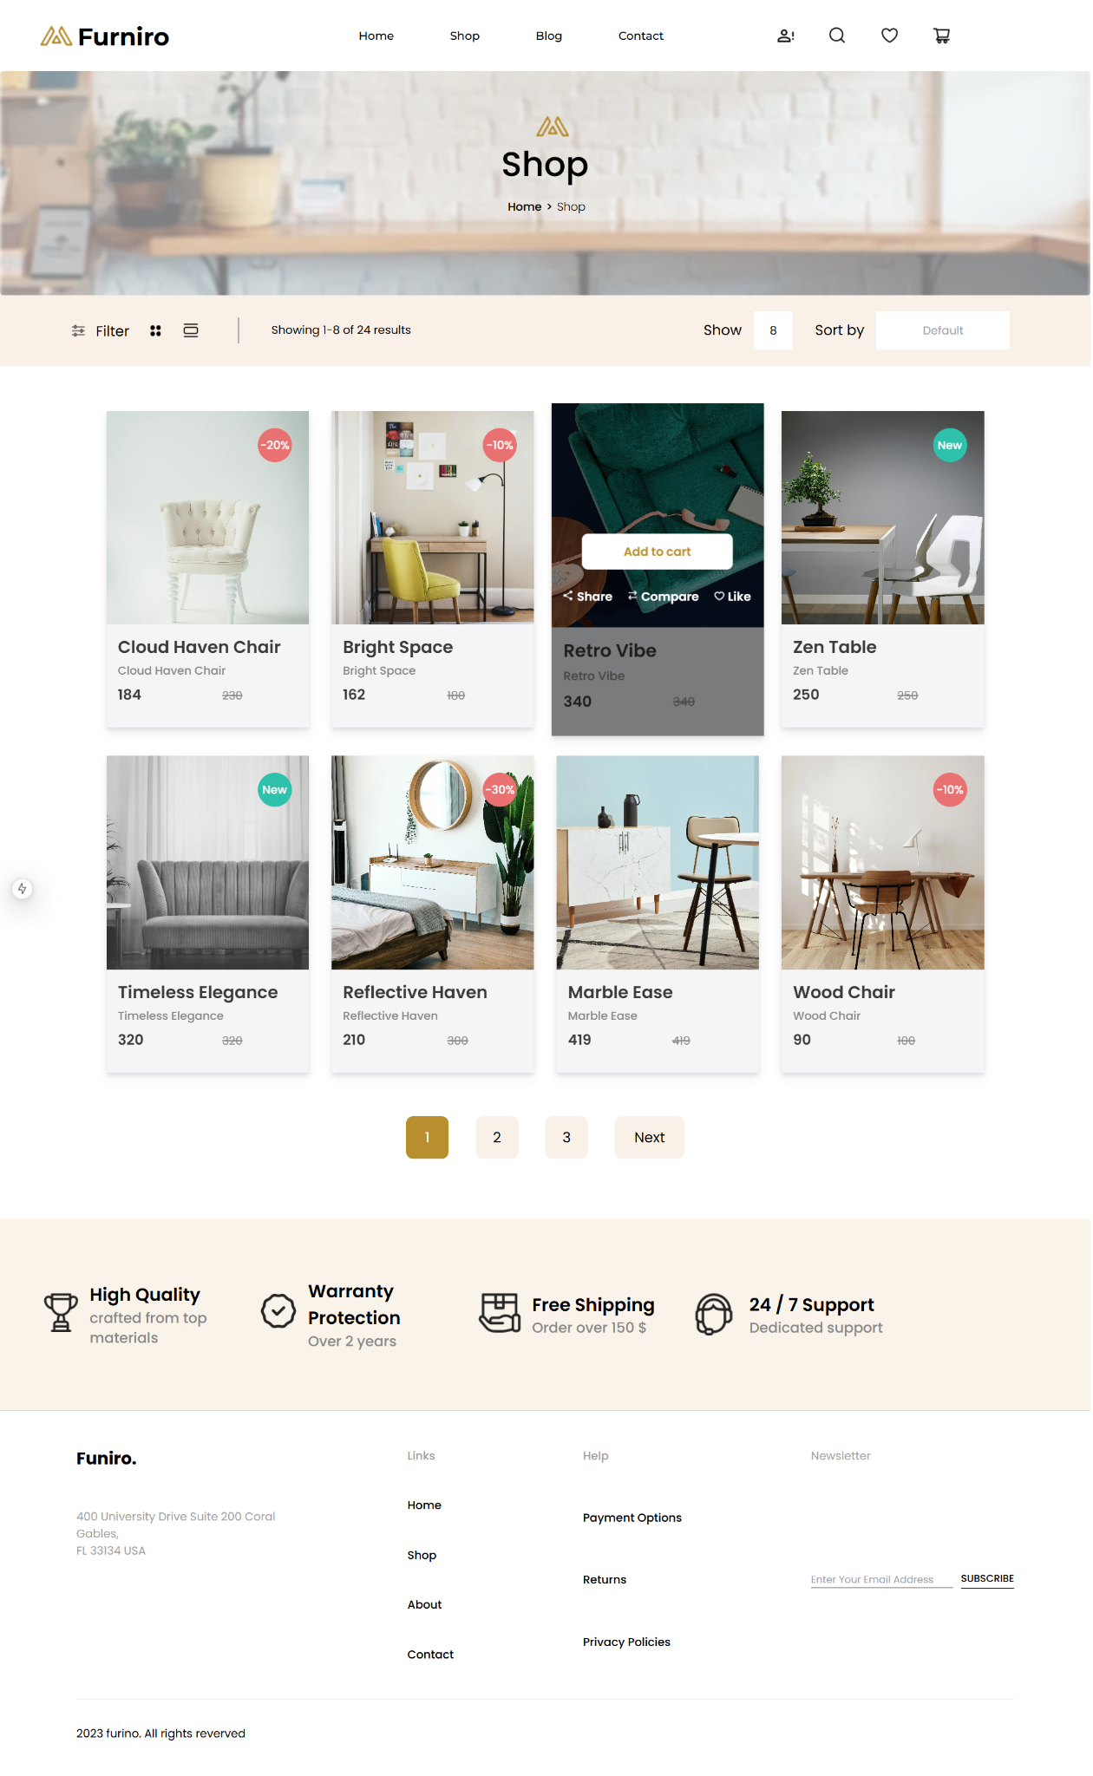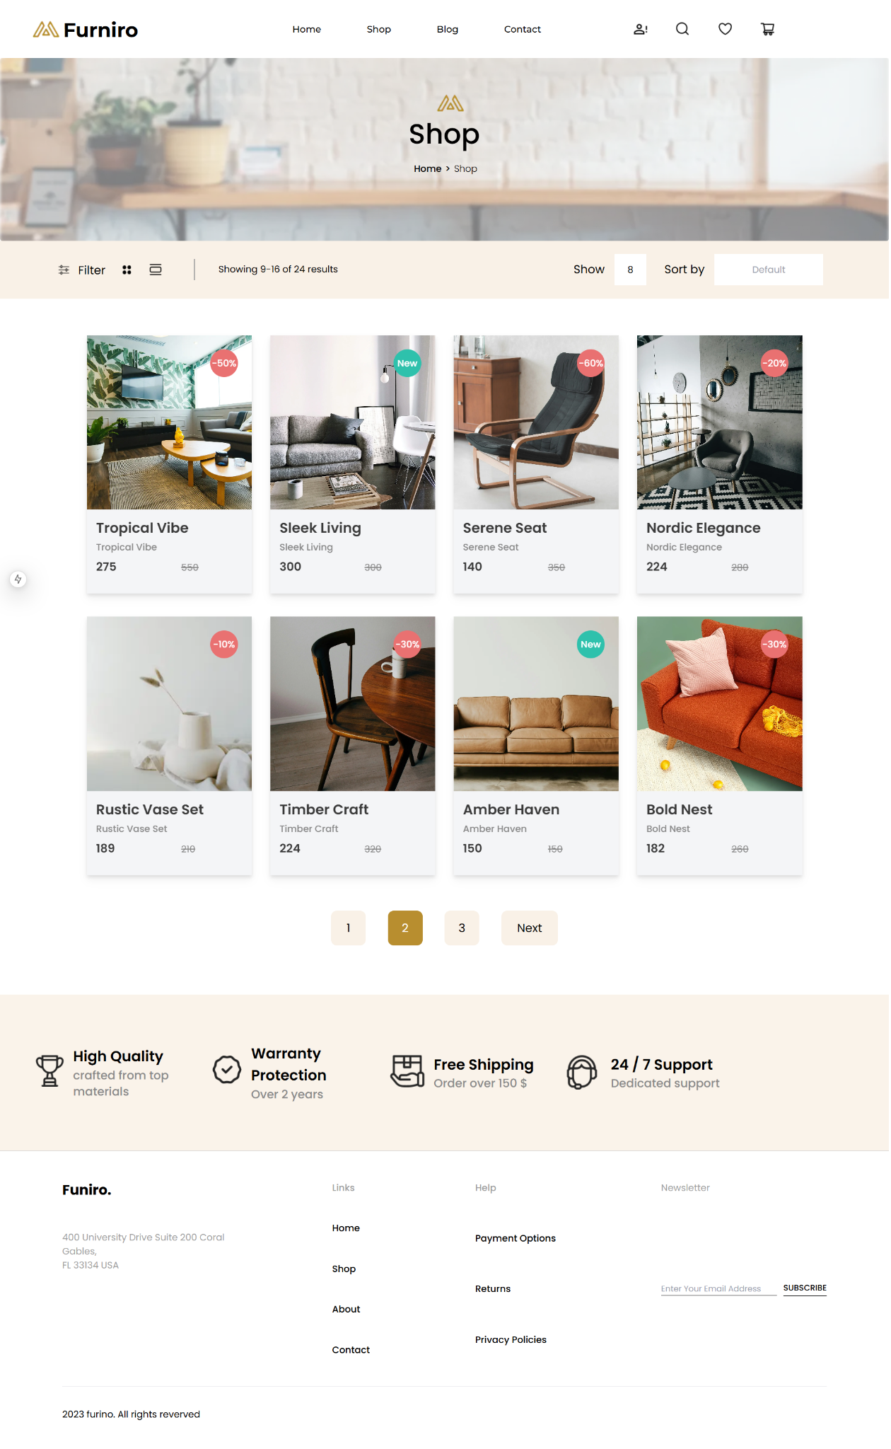

### **Pagination Implementation - Summary:**

1. **State Management**:  
   * Page: Tracks the current, next, and subsequent pages.
   * currentPage: Keeps track of the current active page.
   * defaultValue: Sets the number of products shown per page.
   * ShowData: Holds the currently displayed products based on pagination.
2. **Pagination Functions**:  
   * **handlePageChange**: Updates products based on selected page and recalculates the displayed range.
   * **HandleNext**: Moves to the next set of pages if there are more pages available.
   * **handleinput**: Allows users to input the number of products per page and updates defaultValue on pressing Enter.
3. **UI Elements**:  
   * Filters, sort options, and product display options.
   * Pagination controls with page numbers and "Next" button to navigate.
   * Product display grid with image, title, price, and action buttons like "Add to Cart", "Share", etc.
4. **Edge Case Handling**:  
   * Hides pagination buttons if they exceed the total product count.
   * Adjusts the page range and data based on the number of products to display.
5. **Conclusion**:  
   * Efficiently manages pagination, dynamically displaying products and adapting to user input while handling product count limitations.

**Footer and Header Components:**

* Build consistent navigation and branding elements.
* Include links to key pages (e.g., Home, About, Contact).
* Ensure responsiveness and accessibility.



'use client'

import {useState } from 'react'

import { Montserrat } from 'next/font/google'

import Image from 'next/image'

import Link from 'next/link'

import { Producttype } from '../types/Product'

const montserrat = Montserrat({

subsets: ['latin'],

})

const Navibar = () => {

// State to toggle the mobile menu

const [mobileMenuOpen, setMobileMenuOpen] = useState(false)

const [showcartlist,setCartlist] = useState(false)

const [Product,setProducts] = useState<Producttype[]>([])

const [total,setTotal]=useState(0)

function showlist()

{

const cart = JSON.parse(localStorage.getItem('cart') || '{}');

const item:Producttype[]=Object.values(cart) ;

setProducts(Object.values(cart));

if(item.length >0)

{

let dummytotal=0;

for (const i of item){

dummytotal+=i.price * i.Quantity;

}

setTotal(dummytotal)

}

setCartlist(!showcartlist)

}

const removeproduct = (ele:Producttype)=>{

const cart = JSON.parse(localStorage.getItem('cart') || '{}');

delete cart[ele.title];

localStorage.setItem('cart', JSON.stringify(cart));

setProducts(Object.values(cart))}

return (

<div className={`${montserrat.className} relative w-full h-[100px]`}>

{/* Logo – remains in the same position */}

<div className="absolute w-[185px] h-[41px] top-[29px] left-[54px] flex gap-[5px] items-center justify-center">

<div className="w-[50px] h-8">

<Image

src="/Navbar/websitelogo.png"

alt="Furniro Logo"

width={50}

height={32}

/>

</div>

<h1 className="w-[130px] h-[41px] text-[34px] mb-1 font-bold">Furniro</h1>

</div>

{/* Desktop Navigation Links (visible on md and larger) */}

<div className="hidden md:block bg-white font-medium text-[16px] absolute top-[38px] left-[505px] w-[430px] h-6">

<ul className="flex justify-between">

<li>

<Link href="./">Home</Link>

</li>

<li>

<Link href="../shop">Shop</Link>

</li>

<li>

<Link href="./blog">Blog</Link>

</li>

<li>

<Link href="./contact">Contact</Link>

</li>

</ul>

</div>

{/* Desktop Icons (visible on md and larger) */}

<div className="hidden md:flex absolute top-9 left-[1093px] w-[247px] h-7 justify-between">

<div className="relative w-7 h-7">

<Image

src="/Navbar/user.png"

alt="User"

width={23.33}

height={18.67}

className="absolute top-[4.67px] left-[2.33px]"

/>

</div>

<div className="relative w-7 h-7">

<Image

src="/Navbar/search.png"

alt="Search"

width={22.17}

height={22.17}

className="absolute top-[2.33px] left-[2.33px]"

/>

</div>

<div className="relative w-7 h-7">

<Image

src="/Navbar/whishlist.png"

alt="Wishlist"

width={23.33}

height={20.81}

className="absolute top-[3.5px] left-[2.33px]"

/>

</div>

<div className="relative w-7 h-7">

<button onClick={showlist}> <Image

src="/Navbar/cart.png"

alt="Cart"

width={24.53}

height={22.06}

className="absolute top-[3.55px] left-[1.67px]"

/> </button>

</div>

</div>

{/* Mobile Hamburger Button (visible on mobile only) */}

<div className="absolute top-[29px] right-[20px] md:hidden flex items-center">

<button onClick={() => setMobileMenuOpen(!mobileMenuOpen)}>

{/* Hamburger icon SVG */}

<svg

className="w-8 h-8"

fill="none"

stroke="currentColor"

viewBox="0 0 24 24"

>

<path

strokeLinecap="round"

strokeLinejoin="round"

strokeWidth={2}

d="M4 6h16M4 12h16M4 18h16"

/>

</svg>

</button>

</div>

{/* Mobile Menu Overlay – toggled with hamburger */}

{mobileMenuOpen && (

<div className="md:hidden absolute top-[100px] left-0 w-full bg-white shadow-md z-50">

{/* Nav links in vertical layout */}

<ul className="flex flex-col items-center py-4 space-y-4 font-medium text-[16px]">

<li>

<Link href="./" onClick={() => setMobileMenuOpen(false)}>

Home

</Link>

</li>

<li>

<Link href="../shop" onClick={() => setMobileMenuOpen(false)}>

Shop

</Link>

</li>

<li>

<Link href="./blog" onClick={() => setMobileMenuOpen(false)}>

Blog

</Link>

</li>

<li>

<Link href="./contact" onClick={() => setMobileMenuOpen(false)}>

Contact

</Link>

</li>

</ul>

{/* Icons for mobile (if you want them shown here too) */}

<div className="flex justify-center space-x-4 pb-4">

<div className="relative w-7 h-7">

<Image

src="/Navbar/user.png"

alt="User"

width={23.33}

height={18.67}

/>

</div>

<div className="relative w-7 h-7">

<Image

src="/Navbar/search.png"

alt="Search"

width={22.17}

height={22.17}

/>

</div>

<div className="relative w-7 h-7">

<Image

src="/Navbar/whishlist.png"

alt="Wishlist"

width={23.33}

height={20.81}

/>

</div>

<div className="relative w-7 h-7">

<Image

src="/Navbar/cart.png"

alt="Cart"

width={24.53}

height={22.06}

/>

</div>

</div>

</div>

)}

<div onClick={showlist} className={`relative w-full h-[1000px] z-20 right-0 ${showcartlist==false ? "hidden" : ""} `}>

<div className='absolute w-full h-[1000px] bg-black opacity-20'></div>

<div className='absolute w-[430px] h-[746px] bg-white z-20 opacity-100 right-0 grid grid-cols-1 place-content-between'>

<div className=''>

<div className='flex mx-[8%] mt-7 text-2xl font-semibold justify-between items-center'>

<h1>Shopping Cart</h1>

<div className='relative w-[16.63px] h-[19px]'>

<Image src="/Navbar/Group.png" alt="" layout='fill' objectFit='cover '></Image>

</div>

</div>

<div className='border border-[#d9d9d9] mt-7 ml-[8%] mr-[20%]'></div>

<div className="grid gap-5 mt-7">

{Product.map((ele, idx) => (

<div key={idx} className="flex items-center gap-[35px] mx-[8%]">

<div className="w-[108px] h-[105px] relative">

<Image

src={ele.imageurl}

alt={ele.title}

layout="fill"

objectFit="cover"

className="rounded-lg"

/>

</div>

{/* Title */}

<div className='w-full flex justify-between items-center'>

<div className="h-14 grid items-center">

<h1 className="text-[16px] font-normal whitespace-nowrap">{ele.title}</h1>

<div className='flex gap-[15px] text-xs font-light'>

<h1 className='text-[16px] font-light'>{ele.Quantity}</h1>

<h1>X</h1>

<h1 className='font-medium text-[#B88E2F]'>Rs. {ele.price}</h1>

</div>

</div>

<button onClick={()=>{

removeproduct(ele);

}} className='w-5 h-5 rounded-full bg-[#9f9f9f] text-xs text-white font-bold'><p>X</p></button>

</div>

</div>

))}

</div>

</div>

<div className='grid gap-6'>

<div className='mx-[8%] flex gap-[101px] text-[16px] font-normal'>

<h1>Subtotal</h1>

<h1 className='text-[#B88E2F] font-semibold'>Rs. {total}</h1>

</div>

<div className='border border-[#9f9f9f]'></div>

<div className='mx-[8%] flex justify-between mb-6'>

<Link href={"../cart"} >

<button onClick={showlist} className='border border-black rounded-[50px] w-[87px] h-[30px] text-xs font-normal'>Cart</button>

</Link>

<Link href={"../checkout"}>

<button disabled={total==0 || total==undefined} onClick={showlist} className='border border-black rounded-[50px] w-[118px] h-[30px] text-xs font-normal'>Checkout</button>

</Link>

<Link href={""}>

<button onClick={showlist} className='border border-black rounded-[50px] w-[135px] h-[30px] text-xs font-normal'>Comparision</button>

</Link>

</div>

</div>

</div>

</div>

</div>

)

}

export default Navibar

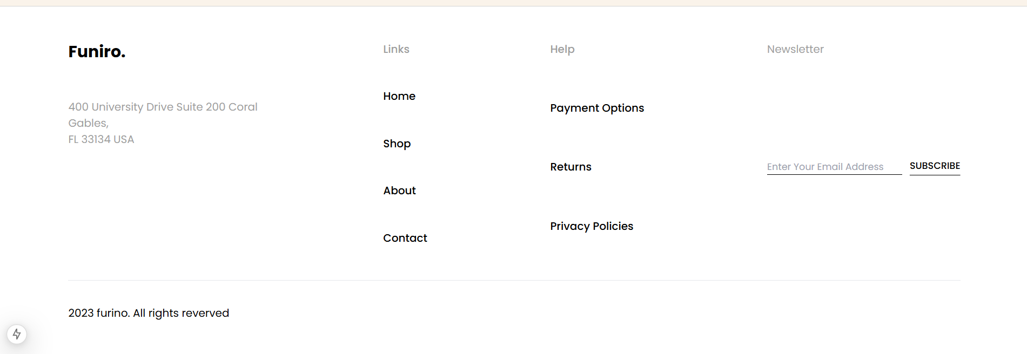

import Link from "next/link";

export default function Footer() {

return (

<div>

<div className="border-t border-black border-opacity-[.17]">

<div className=" mx-[7%] my-[3.3%] flex justify-between flex-wrap">

<div className="w-[285px] h-[158px] grid grid-col-1 gap-[50px]">

<h1 className="w-[85px] h-9 text-2xl font-bold">

Funiro.

</h1>

<p className="w-[290px] h-[72px] text-[#9F9F9F] text-[16px] font-normal">400 University Drive Suite 200 Coral <br />Gables,<br />FL 33134 USA</p>

</div>

<ul className="w-[66px] text-[16] font-medium grid grid-cols-1 gap-[46px]">

<li className="text-[#9F9F9F]">Links</li>

<li><Link href={"/"}>Home</Link></li>

<li><Link href={"./shop"}>Shop</Link></li>

<li><Link href={""}>About</Link></li>

<li><Link href={""}>Contact</Link></li>

</ul>

<ul className="w-[140px] text-[16] font-medium grid grid-cols-1 gap-[46px]">

<li className="text-[#9F9F9F]">Help</li>

<li><Link href={"/"}>Payment Options</Link></li>

<li><Link href={"./shop"}>Returns</Link></li>

<li><Link href={""}>Privacy Policies</Link></li>

</ul>

<div className="w-[286px] grid grid-cols-1 gap-[46px]">

<h1 className="text-[#9F9F9F]">Newsletter</h1>

<div className="flex gap-[11px]">

<input type="email" placeholder="Enter Your Email Address" className="w-[200px] h-6 text-sm font-normal border-b border-black " />

<button className="text-sm font-medium w-[75px] h-[21px] underline underline-offset-[9px]">SUBSCRIBE</button>

</div>

</div>

</div>

</div>

<div className=" mx-[7%] my-[3.3%] border-t" >

<p className="mt-9 text-[16px] font-normal">2023 furino. All rights reverved</p>

</div>

</div>

)

}

### **Summary:**

* **Footer Component:**
  + **Steps Taken:**
    - Created a responsive footer layout with company information, navigation links, and a newsletter section.
    - Used Tailwind CSS for styling and responsiveness.
  + **Challenges Faced:**
    - Ensuring proper alignment and responsiveness across different screen sizes.
  + **Solutions Implemented:**
    - Utilized mx-[7%] and my-[3.3%] for margins and grid for alignment.
    - Added border styles for separation of content sections.
* **Navbar Component:**
  + **Steps Taken:**
    - Designed a logo, navigation links, and icons for user interactions.
    - Implemented dynamic cart functionality using useState and local storage for persisting cart items.
    - Integrated a mobile hamburger menu for smaller screen sizes.
  + **Challenges Faced:**
    - Managing cart data dynamically and ensuring mobile responsiveness.
  + **Solutions Implemented:**
    - Used local storage to retrieve and store cart items.
    - Conditioned the rendering of the cart list and mobile menu based on state changes.
* **Best Practices:**
  + Followed **mobile-first design** for responsiveness.
  + Used **state management** to handle dynamic cart data and visibility toggles.
  + Ensured **clean and reusable code** with Tailwind CSS for styling and component separation.

**Customer Feedback Component:**

* Create a form for users to submit feedback about the marketplace or specific products.
* Display aggregated feedback for admins to review.

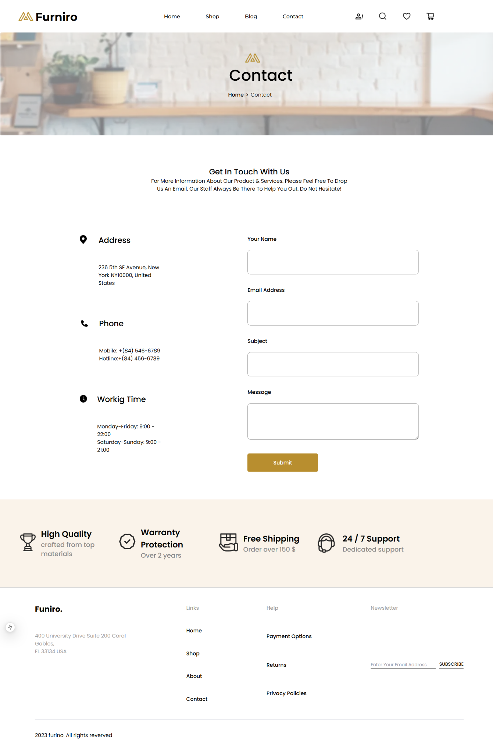

### **Summary:**

* **Contact Component:**
  + **Steps Taken:**
    - Designed a contact form with fields for Name, Email, Subject, and Message.
    - Incorporated static contact details like Address, Phone, and Working Time with relevant icons using Next.js Image component.
    - Managed form data using useState for handling user inputs.
    - Added form validation with required attributes on each field and captured user input changes through handleChange function.
  + **Challenges Faced:**
    - Ensuring form input fields are properly handled, especially with dynamic updates.
    - Managing responsive layout to maintain proper UI on both large and small screens.
  + **Solutions Implemented:**
    - Utilized controlled components in React by storing form data in the component's state.
    - Applied Tailwind CSS to achieve responsive design and easily adjustable spacing.
    - Used Next.js's Image component for optimized image handling.
  + **Best Practices Followed:**
    - **State Management:** Proper state management for form data using useState.
    - **Validation:** Ensured required fields with HTML required attribute and added controlled form inputs.
    - **Responsive Design:** Used Tailwind CSS utility classes for responsiveness to cater to various screen sizes.
    - **Separation of Concerns:** Divided contact details (address, phone, and timing) from the form to keep the component structure clean and modular.

**Social Media Sharing Component:**

* Enable users to share products or promotions directly to social media platforms.
* Integrate APIs for platforms like Facebook, Twitter, and WhatsApp. (If you don't know how to do it, just add the UI; you may make it dynamic later when you find a way.)

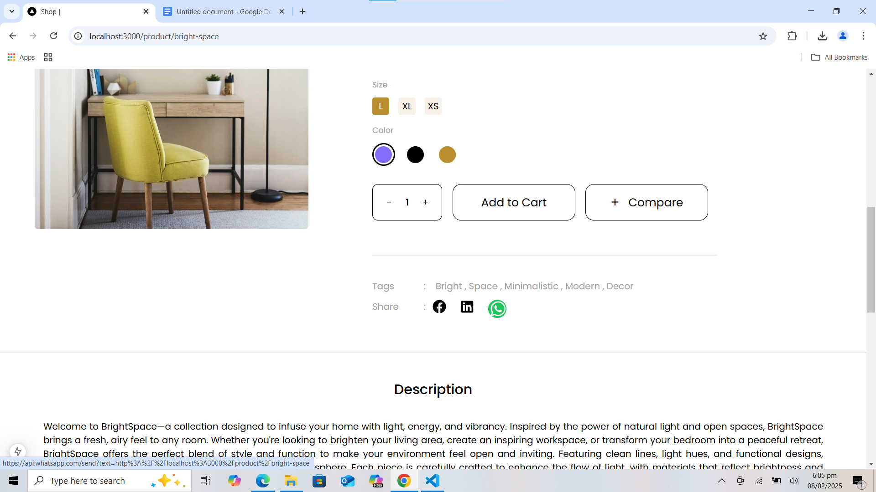

<div className="flex gap-[44px]">

<h1>Share </h1>

<div className="flex gap-3"><p>:</p>

<div className=" flex gap-[25px]">

<a href={`https://www.facebook.com/sharer/sharer.php?u=${encodeURIComponent(currentPageLink)}`}

target="_blank"

rel="noopener noreferrer">

<FaFacebook className="text-2xl text-black hover:text-blue-600 hover:text-3xl active:scale-95" /> </a>

<a

href={`https://www.linkedin.com/shareArticle?url=${encodeURIComponent(currentPageLink)}`}

target="_blank"

rel="noopener noreferrer"

>

<FaLinkedin className="text-2xl text-black hover:text-blue-500 hover:text-3xl active:scale-95" />

</a>

<a

href={`https://api.whatsapp.com/send?text=${encodeURIComponent(currentPageLink)}`}

target="_blank"

rel="noopener noreferrer"

>

<div className="w-7 h-7 bg-black rounded-full relative hover:bg-green-500 hover:w-8 hover:h-8 "> <FaWhatsapp className="absolute left-[1.75px] top-[1px] text-2xl text-white hover:text-3xl active:scale-95" /> </div>

</a>

</div>

</div>

</div>

### **Summary:**

* **Share Component:**
  + **Steps Taken:**
    - Designed a share section with social media links to share content via Facebook, LinkedIn, and WhatsApp.
    - Used FaFacebook, FaLinkedin, and FaWhatsapp icons from the react-icons library for representing each platform.
    - Each social media icon is a clickable link that opens the corresponding platform’s sharing interface in a new tab, passing the current page link (currentPageLink) as the shareable URL.
    - Ensured accessibility by adding rel="noopener noreferrer" to the links for security reasons.
  + **Challenges Faced:**
    - Handling external URLs and ensuring the page links are properly encoded for sharing.
    - Ensuring that the links open in a new tab and provide a seamless sharing experience.
  + **Solutions Implemented:**
    - Used encodeURIComponent() to properly encode the current page link, ensuring it's safe to include in the URL for social media sharing.
    - Applied Tailwind CSS classes to create a responsive and interactive design, with hover and active states for icons to improve the user experience.
    - Used relative positioning for the WhatsApp icon to align it properly within a circular button.
  + **Best Practices Followed:**
    - **Security:** Added rel="noopener noreferrer" to external links to protect against potential vulnerabilities.
    - **Code Readability:** Clean and modular code, ensuring the links and icons are structured logically.
    - **UX/UI Design:** Included hover effects and scaling icons for better interaction and visual feedback.
    - **Reusability:** Used encodeURIComponent() to make sure the page link is universally sharable across multiple platforms.